A1207-Sichuan-Liangshan-Yizu **Laquerware wine set**

**Case no.: 5**

**Accession Number:**

**Formal Label:** Sichuan-Liangshan-Yizu **Laquerware wine tasting set**

**Display Description:**

This **laquerware has been produced in** Yizu Autonomous Prefecture of southern Sichuan **in the mid-20th century by the** Liangshan Yizu Ethnic Minority people in Xichang. (Xichang was formerly known as Jiandu, Jianchang, Caindu, Gaindu, and Kaindu.)Lacquerware manufacturing in Liangshan is an ancient handicraft, which has a history of over 2,000 years. Yizu lacquerwares are characterized by colorful patterns of the Yizu geometric style. Yizu lacquerwares are widely used as tablewares, tea sets, wine sets and ornaments.

**LC Classification:** DS731.Y5

**Date or Time Horizon:** mid-20th century

**Geographical Area:** Sichuan, Liangshan

**Map**

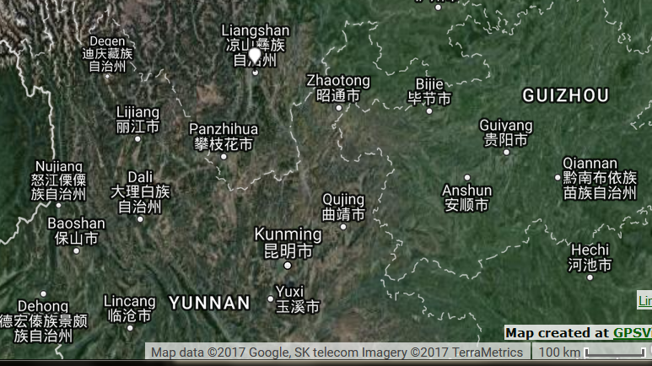

**GPS coordinates:** [27°53′40″N 102°15′52″E](https://tools.wmflabs.org/geohack/geohack.php?pagename=Xichang&params=27_53_40_N_102_15_52_E_region:CN-51_type:city(481796))

**Cultural Affiliation:** Yizu

**Media:** wild cherry wood, red, yellow, black pigments.

**Dimensions:** various

**Weight: various**

**Condition: original**

**Provenance:** Dai Qing, 1998

**Discussion:**

The Yi people live a nomadic life in the forests of Liangshan: they live in the mountains in the summer and descend to the valleys in the winter. The wood selected for Yi lacquerware is wild cherry, aspen, birch and rhododendron, which are found in these forests. The wood is harvested between the Winter solstice and the Spring Festival. During this time the wood is aged in order to prevent deformation and cracking during manufacturing. Painting is the most sophisticated aspect of Yi lacquerware which has the following steps: prime lacquer, filling thinly, grinding, filling deeply, regrinding, and applying a finishing coat.

**References:**

Chen, Yu. 2015. “The Application Research of Liangshan Yi Nationality Lacquer Design Language in Modern Product Design,” *Canadian Social Science*, 11(2).

Song, Li. 2015. *The saizhuang festival of yi ethnic group*. [Reading, England]: Paths International Ltd.